AN ABSTRACT OF THE THESIS OF

Tad Larsen for the degree of Master of Science in Forest Resources presented on July 13, 2004.

Title: Modeling Gray Wolf Habitat in Oregon Using a Geographic Information System

Abstract approved:

William J. Ripple

Gray Wolves (Canis lupus) were once found throughout North America including Oregon. Wolves were extirpated from Oregon due to heavy hunting pressure in the late 19th and early 20th centuries and have been absent for over 50 years. Successful reintroduction efforts in Idaho and the greater Yellowstone area have caused wolf populations in the Rocky Mountain region to rise dramatically, giving way to wolf dispersal into Oregon. This research used logistic regression and a Geographic Information System (GIS) to model and assess potential wolf habitat in Oregon. Models based on previous research were analyzed to find the best approximating wolf habitat model. These a priori models were formulated under the hypotheses that wolf habitat (1) will include relatively high densities of prey, (2) will be limited by human influence, (3) will include favorable landscape characteristics (e.g. forest cover, public ownership), and (4) may be influenced by some combination of these factors. The final model was tested and validated with wolf pack data from the Rocky Mountain region. The results show that a habitat model including variables of forest cover and public land can successfully predict wolf habitat in the study area. These results may assist natural resource managers in developing and implementing of a wolf management plan in Oregon. In addition, because the data used for the habitat model are consistent across state boundaries and are easily accessible, these results may extend to other western states.

© Copyright by Tad Larsen
July 13, 2004
All Rights Reserved

Modeling Gray Wolf Habitat in Oregon Using a Geographic Information System

by
Tad Larsen

A THESIS
submitted to
Oregon State University

in partial fulfillment of
the requirements for the
degree of

Master of Science

Presented July 13, 2004
Commencement June 2005

Master of Science thesis of Tad Larsen presented on July 13, 2004.

APPROVED:

Major Professor, representing Forest Resources

Head of the Department of Forest Resources

Dean of the Graduate School

I understand that my thesis will become part of the permanent collection of Oregon State University libraries. My signature below authorizes release of my thesis to any reader upon request.

Tad Larsen, Author
ACKNOWLEDGEMENTS
Facilities and research support were provided by the Environmental Remote Sensing Applications Laboratory (ERSAL) through the Forest Resources department in the College of Forestry, Oregon State University. I would like to thank my committee, Bill Ripple, Bob Anthony, Bob Beschta, and Kate Lajtha. I would also like to thank the Oregon Department of Fish and Wildlife, Idaho Department of Fish and Game, Montana Department of Fish, Wildlife, and Parks, and Todd Black from Utah State University for providing the necessary data for this project. Thanks to Betsy Glenn, Katie Dugger, and Jo Anne Larsen for your reviews. Thanks are also in order for the staff, faculty, and fellow graduate students in the Forest Resources department and all the family and friends that have been so supportive through the process. Finally, special thanks go to Jen for always being there for me.

TABLE OF CONTENTS

Page

CHAPTER 1: INTRODUCTION.............................................................................1

Background...................................................................................................1

Literature Cited.............................................................................................3

CHAPTER 2: MODELING GRAY WOLF HABITAT IN OREGON USING A

GEOGRAPHIC INFORMATION SYSTEM...................................5

Abstract.........................................................................................................6

Introduction...................................................................................................7

Prey Availability...............................................................................8

Human Presence..............................................................................10

Landscape Characteristics...............................................................13

Previous Models..............................................................................14

Methods.......................................................................................................16

Study Area.......................................................................................16

Spatial Data.....................................................................................17

Model Selection..............................................................................21

Model Application..........................................................................25

Estimating Capacity........................................................................25

Results.........................................................................................................26

Spatial Data.....................................................................................26

Model Selection..............................................................................27

TABLE OF CONTENTS (Continued)

Page

Model Application..........................................................................30

Estimating Capacity........................................................................32

Discussion...................................................................................................32

Spatial Data.....................................................................................32

Model Selection..............................................................................36

Model Application..........................................................................36

Estimating Capacity........................................................................39

Acknowledgements.....................................................................................41

Literature Cited...........................................................................................42

CHAPTHER 3: CONCLUSIONS..........................................................................48

BIBLIOGRAPHY...................................................................................................49

APPENDICES........................................................................................................55

LIST OF FIGURES
Figure Page
2.1 Wolf packs in relation to random “non-pack” polygons............................24
2.2 Modeled wolf habitat >50% in the Rocky Mountain region......................31
2.3 Modeled wolf habitat >50% in Oregon......................................................33
2.4 Modeled wolf habitat >50% in Oregon including private industrial forests in western Oregon.......................................................................................38

LIST OF TABLES
Table Page
2.1 Summary of variables used in logistic regression models..........................23
2.2 Statistical comparisons for habitat variables between packs (n = 50) and
random non-pack polygons (n = 50)...........................................................27
  - Summary of logistic regression models for wolf habitat vs. non-habitat in
Idaho...........................................................................................................29

LIST OF APPENICES
Appendix Page
1. Forest cover in Northwest United States.............................................................56
2. Public ownership in Northwest United States.....................................................57
3. Predicted wolf habitat >50% in Northwest Unites states....................................58
4. Elk winter range in Oregon.................................................................................59
5. Elk summer range in Oregon..............................................................................60
6. Deer winter range in Oregon...............................................................................61
7. Deer summer range in Oregon............................................................................62
8. Ungulate density in Oregon (Ungulate Biomass Index/sq. km).........................63
9. Road density in Oregon (km/sq. km)..................................................................64
10. LandScan human presence data in Oregon (humans/sq. km)...........................65
11. 2000 U.S. Census bureau human density in Oregon (humans/sq. km).............66
12. Average annual precipitation in Oregon (mm.)................................................67
13. Ungulate population estimates by wildlife management unit...........................68

CHAPTER 1
INTRODUCTION

Background
Gray wolves (Canis lupus) once ranged throughout North America including Oregon, where they were common in western Oregon as well as east of the Cascades (Bailey 1936; Young and Goldman 1964; Mech 1970). As settlers made their way west into Oregon, wolves were hunted relentlessly for their fur and in order to reduce their impact on livestock and game animals (Wuerthner 1996). As a result of this intense hunting pressure and the unregulated hunting of ungulates, their main source of prey, wolves were eventually extirpated from the conterminous 48 states, with the exception of a small number in the northern Great Lakes region (Mech et al. 1995; Mladenoff and Sickley 1998; ODFW 2003). By 1930, wolves were rare in Oregon and in the latter half of the century only scattered reports of wolves were recorded (Wuerthner 1996; Carroll et al. 2001). The last documented wolf in Oregon was killed in 1946 in the Umpqua National Forest (ODFW 2003).
In 1974 the Endangered Species Act gave protection to wolves in the continental United States and since then they have reestablished and increased in numbers in several states in the Great Lakes and northern Rocky Mountain regions (Mech et al. 1995; Fuller 1995; Mladenoff et al. 1995; Pletscher et al. 1997). For example, the wolf population in Minnesota has tripled from 700 in 1974 to more than 2445 in 1998 and wolves from this area have dispersed into northern Wisconsin (335 wolves estimated in 2003) and Upper Michigan (321 wolves estimated in 2003) (Mladenoff and Sickley 1998; USFWS 2004). Wolves have also dispersed from Canada into northwestern Montana and through Glacier National Park (Boyd et al. 1995). In addition, wolves were reintroduced into Yellowstone National Park (31 wolves) and central Idaho (35 wolves) in 1995–1996 (USFWS et al. 2002). Currently, there are an estimated 108 wolves in northwestern Montana, 271 in the Greater Yellowstone ecosystem, and 285 in central Idaho (USFWS et al. 2002; USFWS 2004). Mexican gray wolves were also reintroduced into the Southwest U.S. (Arizona/New Mexico), but the establishment of these populations has been slow and less successful with latest estimates at 21 wolves (74 were originally introduced; USFWS 2004)
Because the numbers of northern gray wolves have increased so dramatically in many areas, wolves have started dispersing into surrounding states. For example, three wolves have been documented in Oregon in the past 5 years (ODFW 2003). One radiocollared wolf was captured and returned to Idaho and the other two were found dead. These dispersing wolves sparked a political debate as to whether or not wolves should be allowed to recolonize areas of Oregon. This research will attempt to focus primarily on the ecological aspect of wolf recovery in order to answer the question: What is the potential for gray wolf recovery in Oregon?

Literature Cited
Bailey, V. 1936. The mammals and life zones of Oregon. U.S. Department of Agriculture. North American Fauna No. 55. 416pp.

Boyd, D.K., P.C. Paquet, S. Donelon, R.R. Ream, D.H. Pletscher, and C.C. White. 1995. Transboundary movements of a recolonizing wolf population in the Rocky Mountains. in L. N. Carbyn, S.H. Fritts, and D.R. Seip, editor. Ecology and Conservation of Wolves in a Changing World. Canadian Circumpolar Institute, University of Alberta, Edmonton.

Carroll, C., R.F. Noss, N.H. Schumaker, and P.C. Paquet. 2001. Is the return of the wolf, wolverine, and grizzly bear to Oregon and California biologically feasible? Pages 25 - 46 in D. S. Maehr, R.F. Noss, and J.L. Larkin, editor. Large Mammal Restoration. Island Press, Washington.

Fuller, T.K. 1995. Comparative population dynamics of North American wolves and African wild dogs. in L. N. Carbyn, S.H. Fritts, and D.R. Seip, editor. Ecology and Conservation of Wolves in a Changing World. Canadian Circumpolar Institute, University of Alberta, Edmonton.

Mech, L.D. 1970. The wolf: the ecology and behavior of an endangered species. Natural History Press, New York.

Mech, L.D., S.H. Fritts, and D. Wagner. 1995. Minnesota wolf dispersal to Wisconsin and Michigan. American Midland Naturalist 133:368 - 370.

Mladenoff, D.J., and T.A. Sickley. 1998. Assessing potential gray wolf restoration in the northeastern United States: A spatial prediction of favorable habitat and potential population levels. Journal of Wildlife Management 62:1 - 10.

Mladenoff, D.J., T.A. Sickley, R.G. Haight, and A.P. Wydeven. 1995. A regional landscape analysis and prediction of favorable gray wolf habitat in northern Great Lakes region. Conservation Biology 9:279 - 294.

Oregon Department of Fish and Wildlife. 2003. An introduction to Oregon wolf issues. Oregon Department of Fish and Wildlife [online]. Available: http://www.dfw.state.or.us/ODFWhtml/InfoCntrWild/gray_wolf/wolf_main.htm [March 2003].

Pletscher, D. H., R.R. Ream, D.K. Boyd, M.W. Fairchild, and K.E. Kunkel. 1997. Population dynamics of a recolonizing wolf population. Journal of Wildlife Management 61:459 - 465.

U.S. Fish and Wildlife Service (USFWS), Nez Perce Tribe, National Park Service, and USDA Wildlife Services. 2002. Rocky Mountain Wolf Recovery 2001 Annual Report. T. Meier, ed. USFWS, Ecological Services, 100 N Park, Suite 320, Helena MT. 43pp.

U.S. Fish and Wildlife Service (USFWS), Nez Perce Tribe, National Park Service, and USDA Wildlife Services. 2004. Rocky Mountain Wolf Recovery 2003 Annual Report. T. Meier, ed. USFWS, Ecological Services, 100 N Park, Suite 320, Helena MT. 65pp.

Wuerthner, G. 1996. Potential for wolf recovery in Oregon. in N. Fascione, and M. Cecil, editor. Defenders of Wildlife's Wolves of America Conference.

Young, S.P., and E.A. Goldman. 1964. Wolves of North America. Dover, New York.

CHAPTER 2

MODELING GRAY WOLF HABITAT IN OREGON USING A GEOGRPAHIC INFORMATION SYSTEM

Tad E. Larsen and William J. Ripple¹

¹Department of Forest Resources, Oregon State University, Corvallis, OR 97331

Abstract
Gray wolves (Canis lupus) were once widespread throughout most of North America including Oregon. Wolves were extirpated from Oregon due to heavy hunting pressure in the late 19th and early 20th centuries and have been absent for over 50 years. The success of reintroduction efforts in Idaho and the greater Yellowstone area, however, has caused wolf populations in these states to rise dramatically, giving way to wolf dispersal into Oregon. This study used a Geographic Information System (GIS) and wolf pack locations from the Rocky Mountain region to model wolf habitat. A priori models based on previous research were created under the hypotheses that wolf habitat (1) will include a relative high prey density, (2) will be limited by human influence, (3) will include favorable landscape characteristics such as forest cover and public ownership, and (4) may be influenced by some combination of these factors. Logistic regression was used to select the best model for predicting wolf habitat. Results show that the mean probability calculated by the model for observed wolf packs in Idaho was approximately 90%. In addition, model validation efforts show that the mean probability calculated by the model for observed wolf packs in Montana and Wyoming was approximately 80%. Applying the model in Oregon revealed that the state has approximately 68,500 km² of potential wolf habitat and could support a population of approximately 1450 wolves. These results may provide vital information for the development and implementation of a wolf management plan in Oregon.
Introduction
Gray wolves (Canis lupus) were extirpated from the conterminous United States with the exception of a small population in northern Minnesota in the early 20th century due to intense hunting pressure and the unregulated hunting of ungulates, their main source of prey (Mech et al. 1995; Mladenoff and Sickley 1998). Since gaining protection from the Endangered Species Act (1974) and being reintroduced into Yellowstone and central Idaho (1995 – 1996), wolves have begun to recolonize areas in the northern Great Lake states and the Rocky Mountain region (Fuller 1995; Mech et al. 1995; Mladenoff et al. 1995; Pletscher et al. 1997, USFWS et al. 2002). An increase of wolf populations in Idaho has resulted in some wolves dispersing into Oregon to seek out new habitat (ODFW 2003). These dispersing wolves have ignited much controversy regarding the potential of gray wolf recovery in Oregon. This study focused on ecological factors to assess the potential wolf habitat in Oregon.
Because wolves are habitat generalists, they can live in most places in North America that have a sufficient prey base (Fuller et al. 1992; Haight et al. 1998). Conflicts typically occur, however, when they occupy areas close to humans. The majority of wolf mortality is human-caused whether accidental, intentional or indirectly through disease (Mech and Goyal 1993; Mladenoff et al. 1995). Predicting favorable wolf habitat thus becomes a process of locating areas that contain sufficient prey and provide security from humans to lessen conflict (Mladenoff et al. 1995).

Prey Availability
The single most important factor for considering wolf habitat is the availability of prey. A review of documented wolf studies from the various regions throughout North America shows that approximately two-thirds of the variation in wolf density can be explained by variation in prey biomass (Keith 1983; Fuller 1989; Fuller et al. 2003). Thus, an understanding of predator/prey relationships is needed in order to assess the potential availability of wolf habitat.
Although wolves are generally not prey-specific and can subside on small prey and even garbage, large ungulates make up the majority of their diet (Fuller et al. 1992; Haight et al. 1998; Corsi et al. 1999; Fuller et al. 2003). Therefore, the availability and accessibility of ungulates becomes a determining factor for wolves to inhabit areas; the higher the density of ungulates available and susceptible to wolf predation, the better the chances for wolves to succeed (Mech 1970; Keith 1983; Fuller et al. 2003). In North America, ungulates such as elk (Cervus elaphus), deer (Odocoileus virginianus and O. hemionus), moose (Alces alces), caribou (Rangifer tarandus), muskox (Ovibos moschatus), bison (Bison bison), and bighorn sheep (Ovis dalli and O. canadensis) make up the majority of prey base for wolves (Keith 1983; Fuller 1989; Carbyn et al. 1993; Pletscher et al. 1997).
In the eastern portion of North America, white-tailed deer and moose in single prey systems typically constitute the majority of a wolf’s diet (Mech 1970; Peterson 1999). However, in the northern and western portions, many different combinations of ungulate species including elk, moose, caribou, muskox, mule or black-tailed deer, and bighorn sheep can be available to wolves in a multi-prey system (Ballard et al. 1987; Weaver 1994; Fuller et al. 2003). In addition, beaver and hares are important secondary prey in the spring and summer seasons (Fuller 1989; Weaver 1994; Jedrzejewski et al. 2002). Due to the relatively small biomass of beavers and hares, however, ungulates (primarily immature ungulates) still make up the greater prey biomass during these times (Fuller 1989; Mech and Peterson 2003).
Several studies in western North America have found that in terms of biomass, elk are the most important prey species for wolves (Huggard 1993b; Weaver 1994; Smith et al. 2000; Peterson and Ciucci 2003). In a review of western North America studies, Weaver (1994) found wolf predation on elk and deer to be roughly equal in numbers (42%), but the elk were far more important in terms of biomass (56% for elk compared to 20% for deer). Huggard (1993b) found that wolves in the Bow River Valley in Banff National Park relied much more heavily on elk than mule deer or sheep. While wolves rarely preyed on bighorn sheep due to their ability to stay in difficult terrain (steep slopes and high elevations), they showed no preference based on number of encounters with each species. Huggard (1993b) suggested that wolves found elk herded in locations that were more predictable than mule deer, which were found more randomly in smaller groups or by themselves. Although herding can be used by elk as an anti-predator strategy, it may also increase their rate of encounters with wolves, thereby increasing the overall success of wolf predation (Boyd 1978; Hebblewhite and Pletcher 2002; Mech and Peterson 2003). In addition, Weaver (1994) found that the average chase distance was also relatively short for elk compared to deer suggesting a high benefit/cost ratio for wolves preying on elk.
The presence of ungulates alone, however, may not be simply enough to constitute wolf habitat. There needs to be enough biomass for wolves to survive. Mech (1970) concluded that a single wolf requires a minimum of 1.4 kilograms of biomass per day to survive. This is equivalent to 13 deer (at an average 45 kg) per year (Mech and Peterson 2003). Studies on captive wolves have shown, however, the biomass consumption per wolf to be over double (3kg/wolf/day) that of Mech’s (1970) estimated minimum (Mech and Peterson 2003). Studies on wild wolves have shown kill rates to vary anywhere from 0.5 to 24.8 kg/wolf/day (Mech and Peterson 2003).

Human presence

Road density
In addition to prey availability, wolves require areas that minimize wolf-human conflicts (Mech 1995; Mladenoff et al. 1995). One of the most important factors in determining suitable wolf habitat is road density (Theil 1985; Fuller et al. 1992; Mladenoff et al. 1995). In some cases lightly traveled roads can be used as travel corridors by wolves, but wolves often avoid roads that are heavily traveled and easily accessible by humans (Thurber et al. 1994; Mladenoff et al. 1995). Human interactions with wolves are a primary source of wolf mortality due to legal, illegal, and accidental killings or indirectly through disease (Theil 1985; Mech 1989; Mladenoff et al. 1995).
Theil (1985) found that wolf breeding occurred in areas with a road density of ≤0.59 km/km² (linear kilometers of roads per square kilometer) in 13 northern Wisconsin counties. He also determined that >0.60 km/km², “wolf status transformed from breeding to non-breeding and absent” (Theil 1985). Other studies in Minnesota and Michigan provided similar results and a basis for assessing wolf habitat suitability in the Lake States (Jensen et al. 1986; Mech et al. 1988). Later studies, however, revealed that road densities can be higher in areas where wolves are present, suggesting that effects of road density may differ in various situations (Mech 1989; Fuller et al.1992; Light and Fritts 1994; Merrill 2000). Mech (1989) found his study area containing wolves in Minnesota had 26% more roads than similar habitat areas that did not contain wolves and concluded “relatively small areas of high road densities can sustain wolves so long as suitably roadless reservoirs are nearby.” Merrill (2000) also found that wolves were present at Camp Riley in Minnesota where the road density was calculated to be 1.4 km/km². He felt this exception of relatively high road density was likely due to the slower traffic speeds (limit of 40 km/hr) and attitudes of humans that encountered wolves (Merrill 2000).
Mladenoff et al. (1995) found most wolf pack areas in Minnesota contained road densities of ≤0.45 km/km² with none of the pack areas containing road densities >1 km/km². Later studies confirmed wolves were very unlikely to establish packs in areas with road densities ≥1 km/km² (Mladenoff et al. 1999). However, dispersing wolves have been shown to travel through areas of high road densities in order to find suitable habitat (Mech et al. 1995). Since wolves are not necessarily deterred by the roads themselves, but rather humans that use the roads, the difficulty with measuring road density for habitat models becomes an issue of human activity. And, while the level of road usage may be a relatively accurate measure for habitat modeling, such information is rarely available. Mladenoff et al. (1995) compensated for the difference in road usage by omitting lesser used roads such as unimproved forest roads and trails, whereas Carroll et al. (2001) weighted paved highways more heavily than unpaved roads.
Scale is an important factor when considering road density. GIS road data at a large geographic scale (i.e. 1:24,000) will contain far more roads than layers at a small geographic scale (i.e. 1:1,000,000). Previous wolf models have used GIS road data at scales anywhere from 1:20,000 to 1:200,000 although a 1:100,000 scale is used most frequently (Mladenoff et al. 1995; Corsi et al. 1999; Carroll et al. 2001; Singleton et al. 2002).

Human density
In the Great Lakes region, Fuller et al. (1992) found that most wolf packs (88%) in Minnesota were located in areas where human density was ≤8 humans/km². Mladenoff et al. (1995) found that the mean human density in wolf pack areas in the Great Lakes region was 1.5 humans/km². Light and Fritts (1994) found dispersing wolves in the Dakotas to be in areas with a mean human density of 3.5 humans/km², with 8.2 humans/km² being the greatest human density. Human density can be difficult to assess because most data are only available at the census tract/block or county level which can vary significantly in size between tracts/blocks or counties. Mladenoff et al. (1995) and Carroll et al. (2001) used census block data to measure human density.
Human attitudes towards wolves may be more of a driving factor than human density alone (Mech 1995; Mladenoff et al. 1995; Corsi et al. 1999; Fritts et al. 2003), but attitude is difficult to map. If current trends of more positive public attitudes towards wolves continue, wolves will likely be able to withstand higher densities of humans than current models indicate (Mech 1995).

Landscape characteristics
Several landscape characteristics have also been found to be associated with wolf habitat. These characteristics may not be a requirement by wolves per se, but rather may provide additional security from human contact (Singelton et al. 2002; Boitani 2003). Mladenoff et al. (1995) found that public land ownership was strongly related to favorable wolf habitat in the Great Lakes region. Houts (2000) also found that land ownership was significantly different between wolf and non-wolf locations in the northern Rocky Mountain region. Low human density and low road density, in addition to a greater amount of wilderness areas, make public land generally suitable for wolf habitat. Mladenoff et al. (1995) also found that private industrial forest ownership was strongly related to favorable wolf habitat.
Forest cover has also been shown to be strongly related to wolf habitat since it provides habitat for avoiding humans (Boitani 2003). In the Great Lakes region, Mladenoff et al. (1995) found that although most pack areas were located within mixed or deciduous forest, over 92% of all wolf pack areas were located within some type of forest. In the Rocky Mountain region, Houts (2000) also found forest cover (mainly conifer dominated) to be a significant component of wolf habitat.
Wolves in the Rocky Mountain region have also been known to concentrate hunting activities and movements in valley bottoms, avoiding high elevations and steep terrain (Huggard 1993b; Paquet et al. 1996; Carroll et al. 2001; Singleton et al. 2002). However, these preferences may vary between seasons and between dispersing versus territorial movements (Carroll et al. 2000; Singleton et al. 2002).
Snow depth can also play an important role in prey accessibility (Nelson and Mech 1986; Huggard 1993a; Hebblewhite et al. 2002). In areas of deep snow, ungulates have less forage available causing their condition to deteriorate. Having a heavier foot load than wolves, deep snow also makes escape difficult for ungulates (Mech and Peterson 2003).

Previous models
Several GIS-based models have proven to be effective at predicting habitat suitability for large carnivores including wolves (Clark et al. 1993; Mladenoff et al. 1995; Schadt et al. 2002; Fernandez et al. 2003). Mladenoff et al. (1995) used logistic regression to map the probability of wolf habitat in Wisconsin. Stepwise logistic regression resulted in a model with a road density term to be effective in assessing wolf habitat throughout the region (Mladenoff et al. 1995). Later studies corroborated these earlier results (Mladenoff et al. 1999). Subsequently, other wolf habitat models have been applied to various areas in the northern Rocky Mountains, Colorado, and Italy (Corsi et al. 1999, Houts 2000, Carroll et al. 2002)
Only one study known to date has modeled wolf habitat in Oregon (Carroll et al. 2001) and it was based on prey availability, prey accessibility, and security from humans. In order to estimate prey availability, the authors developed a linear regression model using deer abundance data and forage availability that was based on a transformation of remotely sensed imagery called “tassled-cap” greenness (Crist and Cicone 1984). They used this model to predict prey density in the study area and found that although deer harvest data were correlated with greenness in Oregon (r² = 0.41), elk harvest data were not (Carroll et al. 2001). Since elk would be a main source of prey biomass in Oregon, this prey density model was not a good predictor for prey availability. Prey accessibility (Y) was estimated by omitting areas with a steep slope; slope was modeled with the equation: Y = 28.18 * 0.93^{x}, where x = slope in degrees. Road density along with human density was used to evaluate security from humans. The authors did not test or validate the model, however, with any measure of wolf habitat (e.g. presence/absence data).
The objectives of this study were to provide a more comprehensive model for predicting wolf habitat in Oregon. Logistic regression was used to select the best approximating wolf habitat model from a set of a priori models based on the previous wolf research. These a priori models will be grouped under the hypotheses that wolf habitat (1) will include relatively high densities of prey (Keith 1983; Fuller 1989; Fuller et al. 2003), (2) will be limited by human influence (Theil 1985; Fuller et al. 1992; Mladenoff et al. 1995), (3) will include favorable landscape characteristics such as forest cover and public ownership (Mladenoff et al. 1995; Houts 2000), and (4) may be influenced by some combination of these factors.

Methods

Study area
The study area for this project includes Oregon, Idaho, Montana, and Wyoming. These states have many similar characteristics including diverse ecosystems, large amounts of public land and wilderness areas, and similar ungulate species. Although wolves have been absent from Oregon for over 50 years, wolves were reintroduced into Yellowstone National Park (31 wolves) and central Idaho (35 wolves) in 1995–1996 (USFWS et al. 2002). In addition, wolves have dispersed from Canada into northwestern Montana and through Glacier National Park (Boyd et al. 1995). Currently, there are an estimated 108 wolves in northwestern Montana, 271 in the Greater Yellowstone ecosystem, and 285 in central Idaho (USFWS et al. 2002; USFWS 2004). Since wolves currently reside in Idaho, Montana, and Wyoming but not in Oregon, the models were created for Idaho, and the best model was tested in Idaho, Montana, and Wyoming and then applied to Oregon.

Spatial data
Three main factors generally need to be addressed when assessing wolf habitat: sufficient prey available, low levels of human influence, and adequate landscape characteristics (e.g. forest cover and land ownership). In order to address the availability of prey in Oregon, data sets were created illustrating ungulate range and density. Thus, range maps were developed for elk (Cervus elaphus) and deer (Odocoileus hemionus and O. virginianus), the main source of prey accessible to wolves in Oregon.
Range maps for elk and deer were created by consulting wildlife biologists from the Oregon Department of Fish and Wildlife (ODFW). Hard copy range maps existed for many of the available counties or wildlife management units. These hard copy maps were digitized into ArcMap (ESRI, Redlands, California, USA) through a process of on-screen digitizing. The first draft of the range maps were given to ODFW wildlife biologists in Oregon for review purposes. Subsequent adjustments recommended by the ODFW biologists were incorporated into the final range maps.
Winter range maps were created separately from summer range maps. Winter range was defined as the area which contains 90% of the individuals of a particular ungulate species over a period beginning with the first hard snow event until spring green-up for average winters (five out of ten winters). Summer range was then defined as the area which contains 90% of the individuals of an ungulate species from the period of spring green-up until the first hard snow event. A total range was created for each species by combining the winter and summer ranges.
Ungulate density data were obtained by applying existing deer and elk population estimates for each wildlife management unit to the area of ungulate range within those management units. In order to do this, the ungulate range maps were overlaid (using the ArcMap union tool) with the management units retaining the population estimates for each management unit. Polygons that were not included within the ungulate range were eliminated from the dataset. Polygons that were included within the ungulate range were then aggregated based on management unit using the ArcMap dissolve features tool resulting in the original ungulate range stratified by management unit. The area for each aggregated polygon was then computed, allowing for density estimates to be determined by dividing the number of ungulates by the area for each polygon. An Ungulate Biomass Index (UBI) was used to normalize the relative biomass of deer and elk, in which the relative biomass of elk were the equivalent of the relative biomass of three deer (Keith 1983; Fuller 1989; Mladenoff et al. 1995; Fuller et al. 2003). Therefore, all UBI values were measured in terms of deer biomass. For example, the UBI value for 300 elk in a management unit would be 900; the same value as a management unit containing 900 deer. These ungulate density calculations were undertaken for elk and deer separately. All ungulate data were converted from vector to raster data with a 1 km² cell size for subsequent analysis.
Road density and human density were used to identify areas with limited human presence. Road densities were calculated from the U.S. Census Bureau 2000 TIGER (Topologically Integrated Geographic Encoding and Referencing) road data (line). These data are equivalent to the solid lines on a USGS 1:100,000 quadrangle (metadata available online at: http://www.census.gov/geo/www/tiger/rd_2ktiger/tlrdmeta.txt). Paved roads and improved unsurfaced roads passable by automobiles were included for density calculations, but unimproved forest roads (e.g. logging roads) and trails were omitted. The Spatial Analyst extension of ArcMap was used with a search radius of 5 km and output cell size of 1 km² to calculate road densities in kilometers of road per square kilometer area (km/km²).
Because most human density data are only available at the census block/tract or county level that can vary in size by hundreds of square kilometers, the accuracy of these data may be questionable for habitat modeling purposes. In order to test a more accurate measure of human impact, LandScan Global Population 2002 data created by the Oak Ridge National Laboratory were used (Dobson et al. 2000). These data have a resolution of 30 arc seconds (approximately 1 km²) and estimate the number of humans per unit area. The dataset was created from a population model that not only incorporates census data, but also roads, slope, land cover, populated places, lights visible from satellites at night, and other factors to result in a global human density grid (Dobson et al. 2000). Because many variables that measure human impact are used, these data may provide a more accurate assessment for modeling wolf habitat than census data alone. In addition, 2000 U.S. Census data at the block group level were used as a measure for human density to provide a comparable dataset to previous models (Mladenoff et al. 1995).
Landscape variables that were found to be significant in previous models (e.g. public ownership and forest cover) were incorporated to provide additional insight into predicting wolf habitat (Mladenoff et al. 1995; Houts 2000). Land ownership was obtained from the U.S. Bureau of Land Management at a 1:100,000 scale. These data were then queried to include only public lands. Land cover data were obtained from the U.S. Geological Survey National Land Cover Data dataset. These data are derived from 30 m Landsat Thematic Mapper (TM) imagery for the conterminous U.S. The data were queried to include only forest cover. The percentage of forest cover and public ownership were converted to a 1 km² continuous layer by running the ArcMap Spatial Analyst neighborhood analysis over a three km radius.
Precipitation data were obtained from the Oregon Climate Service to incorporate as a climatic variable. These data were created from the Parameter-elevation Regressions on Independent Slopes Model (PRISM) and represent average annual precipitation over a 29-year period (Daly et al. 2002). Although precipitation was not used in previous models, I investigated its importance with regard to ecosystem productivity. These data were measured in millimeters of precipitation at a resolution of approximately 4 km².
Topographic variables such as elevation and slope were not included in the analysis although some studies have found them to be of note for certain wolf activities (Paquet et al. 1996). Wolves are likely to be driven from areas of generally low elevations and slopes, however, where human settlements and infrastructures occur (Dobson et al. 2000) and the relationship between topographic features and pack presence/absence on a landscape scale would likely be reversed due to the greater need of wolves to avoid humans.
In order to test the models, wolf pack data were obtained for wolf populations in the Rocky Mountains (Idaho, Montana, and Wyoming). These data were based on GPS and radio-collared tracking locations obtained by National Park Service and US Fish and Wildlife in 2003 (USFWS et al. 2004). The radio-collared wolves were tracked by aircraft a minimum of two times per month and many were tracked more frequently from the ground (USFWS et al. 2004). Wolf pack polygons were created by the minimum convex polygon procedure in the “Animal Movement” extension for ArcView. Where packs were known to exist, but lacked radio-collard locations, polygons of average wolf pack size were created to represent pack locations (Steve Carson, personal communication).

Model selection
In order to find the best overall model for wolf habitat, a priori models based on previous research were separated into four categories (Table 1). The
first category was grouped under a hypothesis that probability of wolf occupancy will increase with some measure of prey availability (H1). To test this hypothesis, models were based on elk, deer, and overall ungulate densities. The second category of models was grouped under a hypothesis that probability of wolf occupancy will decrease with increasing human presence (H2). To test this hypothesis, models were based on road density, human density, and human impact. The third category was grouped under a hypothesis that probability of wolf occupancy will increase with favorable landscape characteristics (H3). To test this hypothesis, models were based on percent of forest cover, percent of public ownership, and precipitation. The fourth category of models was grouped under the hypothesis that there may be an additive effect of prey availability, human presence, and/or favorable landscape characteristics (H4). Therefore, the models with the best-fit values from each of the first three categories was used in all combinations (i.e., H1 + H2; H1 + H3; H2 + H3; and H1 + H2 + H3) to measure the additive effects.
Logistic regression methods were used to compare pack locations with non-pack locations. Non-pack locations were based on random polygons (equal in size to the mean wolf pack size) at least 10 km away from pack polygons in order to minimize spatial autocorrelation (Figure 1) (Mladenoff et al. 1995). The Information Theoretic approach following Burnham and Anderson (2002) was used to select the best models. Small sample size adjusted Akaike’s Information Criterion (AIC_{C}), delta AIC_{C} and Akaike’s weights were used to rank models (Burnham and Anderson 2002). The best model was selected based on lowest AIC_{C} values for each hypothesis.
Table 1. Summary of variables used in logistic regression models.
Models* | Definition of variables
Hypothesis 1 (H1) - Prey availability
UngD | Density of elk and deer per square km (UBI/km²)
ElkD | Density of elk per square km (UBI/km²)
DeerD | Density of deer per square km (UBI/km²)
Hypothesis 2 (H2) - Human presence
RdD | Linear km of road per square km (km/km²)
HuD | Number of humans per square mile from census block
 | group data (humans/km²)
HuP | Measurement of human presence based on LandScan data
 | (humans/km²)
RdD + HuD
Hypothesis 3 (H3) - Landscape characteristics
%For | Percentage of forest cover
%Pub | Percentage of public land
Precip | Annual precipitation (mm)
%For + %Pub
%For + Precip
Hypothesis 4 (H4) - Additive effects
H1 + H2
H1 + H3
H2 + H3
H1 + H2 + H3
*Models based on hypotheses that wolf habitat will be identified by that availability of prey (H1); will be restricted by the presence of human activity (H2); that some landscape characteristics are favorable to wolf habitat (H3); and that there may be an additive effect of prey availability, human presence, or favorable landscape characteristics (H4).
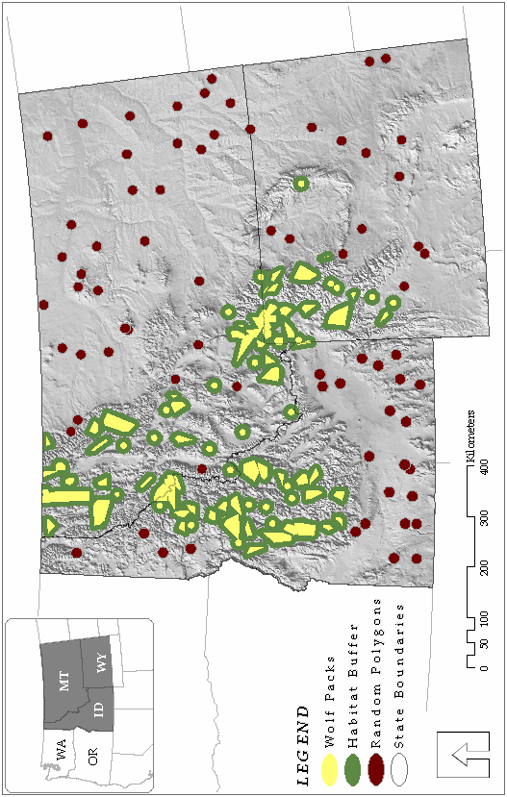
Finally, the best models from each hypothesis were compared to each other to find the best overall wolf habitat model.
Figure 1: Wolf packs in relation to random “non-pack” polygons.

Model application
The a priori model selected to be the best approximating wolf habitat model was applied to Idaho in order to test the accuracy of the model against the wolf pack and random polygons. In addition, the model was applied to Montana and Wyoming and tested against packs and random polygons as a means of validating the model. Success was measured by the assessing the mean probability calculated by the model for observed wolf packs versus the mean probability calculated by the model for random polygons. The model would be considered successful if the model predicted a high probability (>50%) where wolves are present and predicted a low probability (<50%) where wolves are not present. Finally, the model was applied to Oregon in order to identify potential wolf habitat in the state.

Estimating capacity
Predicting how many wolf packs a given amount of habitat will support can be difficult. Wolves are social animals so pack dynamics are very complex to model. In order to avoid predicting the social complexity of wolf packs, estimates of wolf density can be based on the numbers of wolves in relation to prey abundance. Fuller et al. (2003) compiled data from previous research to study the relationship between wolf density and prey availability (Keith 1983; Fuller 1989). Results yielded the following equation:

W = 3.5 + 3.27U
where W is the number of wolves/1000 km² and U is the UBI/km² (r² = 0.64, 31 df, P < 0.001). This equation was used to estimate the number of wolves that could be supported in potential habitat in Oregon based on current prey population estimates. Estimates were grouped together into five regions for analysis: the northeast region, the Cascade region, the Siskiyou/Klamath (southwest) region, the central coastal region, and the northern coastal region. Patches of wolf habitat with a capacity less than four wolves were eliminated from further analysis. This ensured all areas of wolf habitat contained enough prey density to support at least a small number of wolves since prey densities were not included in the final model.

Results

Spatial data
Univariate statistics (Kruskal-Wallis rank sum test) show that most variables included in the models were significantly different (P < 0.001) between pack and non-packs (Table 2) (Mladenoff et al. 1995; Fernandez et al. 2003). The exceptions were deer density and ungulate density which did not show significant differences (P values of 0.070 and 0.065 respectively). Elk density, percent forest,
percent public land, and precipitation were all found to be higher in wolf pack areas than in random polygons. Road density, human density, and human presence were all found to be lower in wolf pack areas than random polygons. These results

supported the initial hypotheses. Deer density and ungulate density, however, were found to be at similar levels between wolf packs and random polygons.
Table 2. Statistical comparisons for habitat variables between packs (n = 50) and random non-pack polygons (n = 50)
Variable | Packs * | Non-Packs * | Χ² | P
RdD (km/km²) | 0.12 ± 0.12 | 0.39 ± 0.30 | 12.82 | <0.001
HuD (hu./km²) | 0.23 ± 0.32 | 3.33 ± 4.56 | 17.98 | <0.001
HuP (hu./km²) | 0.11 ± 0.18 | 2.33 ± 3.69 | 15.62 | <0.001
UngD (UBI/km²) | 3.76 ± 2.02 | 2.79 ± 2.35 | 3.40 | 0.065
ElkD (UBI/km²) | 2.87 ± 1.32 | 1.33 ± 1.79 | 11.50 | <0.001
DeerD (UBI/km²) | 0.85 ± 1.19 | 1.20 ± 1.26 | 3.29 | 0.07
%For (%) | 85.42 ± 18.44 | 19.67 ± 33.26 | 27.50 | <0.001
%Pub (%) | 93.75 ± 12.62 | 53.30 ± 32.25 | 22.34 | <0.001
Precip (mm) | 1012.81 ± 330.95 | 479.52 ± 267.18 | 24.58 | <0.001
All variables were tested using Kruskal-Wallis rank sum test
*Values are means ± 1 SE

Model selection
The best model from the prey availability hypothesis set included elk density (Table 3). This model was 8 AIC_{C} lower than the next best model and received 98% of the Akaike’s weight from this group of models. This elk density variable was retained for inclusion in our final modeling step of building additive models associated with the three main hypotheses. The best model from the human presence hypothesis set included human density based on the 2000 US census data. The model was 3 AIC_{C} lower than the next best model and received 57% of the Akaike’s weight from this group of models. The next closest model was road density and human density, but a correlation matrix showed these variables to be highly correlated (r = 0.77) as were human density and human
presence (r = 0.95). Human density, therefore, was the only model from the second category to be retained for inclusion in the final modeling step. The best model from the landscape characteristics hypothesis included percent forest cover and percent public ownership. The model was 16 AIC_{C} lower than the next best model and received 99% of the Akaike’s weight from this group of models. The percent forest cover and percent public ownership were retained for inclusion in the final modeling step.
The best model from the additive effect hypothesis set included human density, percent forest cover, and percent public ownership. The model was only 0.02 AIC_{C} lower than the next best model which included elk density, percent forest cover and percent public ownership and received 44% of the Akaike’s weight from this group of models as compared to 43% for the next best model. A correlation matrix, however, showed that human density was negatively correlated with public land (r = -0.7). Thus, the best model that contained both parameters was no longer considered for further analyses. The next best model which included elk density, percent forest cover and percent public ownership was used in further analyses.
Comparing the best models from the four hypotheses revealed that the overall best model included percent forest cover and percent public ownership.

Table 3. Summary of logistic regression models for wolf habitat vs. non-habitat in Idaho.
Model* | K | AIC_{C} | ∆_{i} | Akaike W_{i}
Hypothesis 1 (H1)
ElkD | 2 | 62.27 | 0 | 0.98
UngD | 2 | 70.92 | 8.65 | 0.01
DeerD | 2 | 72.42 | 10.15 | 0.01
Hypothesis 2 (H2)
HuD | 2 | 51.20 | 0 | 0.57
RdD + HuD | 3 | 52.68 | 1.48 | 0.27
HuP | 2 | 54.22 | 3.02 | 0.12
RdD | 2 | 56.49 | 5.29 | 0.04
Hypothesis 3 (H3)
%For + %Pub | 3 | 17.87 | 0 | >0.99
%For | 2 | 34.07 | 16.20 | 3.03 * 10⁻⁴
%For + Precip | 3 | 35.41 | 17.54 | 1.55 * 10⁻⁴
Precip | 2 | 43.26 | 25.39 | 3.06 * 10⁻⁶
%Pub | 2 | 45.88 | 28.01 | 8.25 * 10⁻⁷
Hypothesis 4 (H4)
HuD + %For + %Pub | 4 | 20.22 | 0 | 0.44
ElkD + %For + %Pub | 4 | 20.23 | 0.02 | 0.43
ElkD + %For + %Pub + HuD | 5 | 22.69 | 2.47 | 0.13
ElkD + HuD | 3 | 47.81 | 27.59 | 4.47 * 10⁻⁷
Final models
%For + %Pub | 3 | 17.87 | 0 | 0.77
ElkD + %For + %Pub | 4 | 20.23 | 2.36 | 0.23
HuD | 2 | 51.20 | 33.33 | 4.43 * 10⁻⁸
ElkD | 2 | 62.27 | 44.40 | 1.75 * 10⁻¹⁰
*Models based on hypotheses that wolf habitat will be identified by the availability of prey (H1); that wolf habitat will be restricted by the presence of human activity (H2); that some landscape characteristics are favorable to wolf habitat (H3); and that there may be an additive effect of prey availability, human presence, or favorable landscape characteristics (H4).

This model was more than 2 AIC_{C} lower than the next best model and received 77% of the Akaike weight from this group of models. This final model was considered to be the best approximating model for predicting wolf habitat. The equation for this model is as follows:
logit(P) = -21.10(± 10.67) + (0.10 (± 0.05) * %For) + (0.19 (± 0.11) * %Pub)

Model application
The probability of wolf habitat was calculated using the equation:

P = e^{logit(P)} / 1 + e^{logit(P)}
This calculation revealed that there was a significant difference between the mean percent probability for packs (89.9% ± 17.9) and the mean percent probability for random polygons (11.9% ± 17.2) in Idaho (Χ² = 35.37; P < 0.001 from Kruskal-Wallis rank sum test)
Testing the model against the packs and random polygons in Montana and Wyoming showed that the model also worked well in those states (Figure 2). There was a significant difference between the mean percent probability for packs (79.2% ± 11.3) and the mean percent probability for random polygons (5.1% ± 11.3; Χ² = 66.40; P < 0.001 from Kruskal-Wallis rank sum test). In addition, there was no evidence of a difference between pack results in Idaho versus Montana or Wyoming (P = 0.05 from two-sample t-test) or between results of random polygons (P = 0.08 from two-sample t-test).
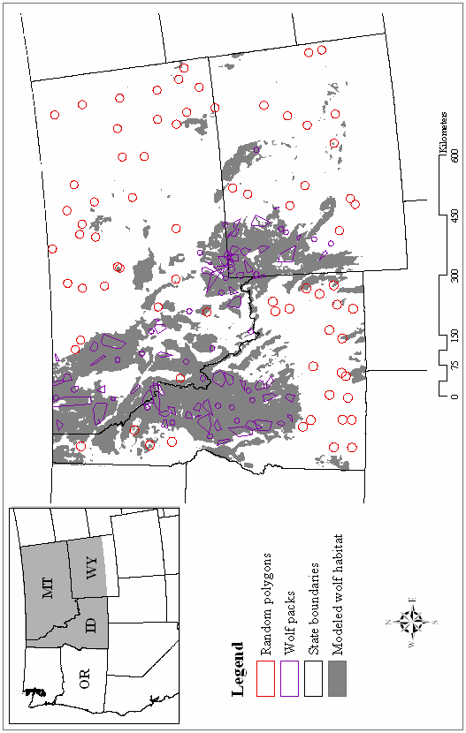
Figure 2: Modeled wolf habitat >50% in the Rocky Mountain region.
A wolf pack probability greater than 50% (Mladenoff et al. 1995; Fernandez et al. 2003) was used in estimating wolf habitat in Oregon. Based on this approach, there is approximately 68,500 km² of wolf habitat in Oregon. The Cascade region has the greatest amount of wolf habitat (approximately 33,500 km²) in Oregon (Figure 3). The northeast region has the next largest portion of wolf habitat (approximately 22,800 km²) followed by the Siskiyou/Klamath (approximately 6500 km²), the central coastal (approximately 3200 km²), and the northern coastal (approximately 2500 km²) regions.

Estimating capacity
Applying the equation developed by Fuller et al. (2003) to the estimated available habitat, Oregon would be able to support approximately 1450 wolves with an average density of 21 wolves/1000 km². The Cascade region would be able to support approximately 600 (18 wolves/1000 km²) wolves, the northeast region approximately 460 (20 wolves/1000 km²) wolves, the Siskiyou/Klamath region approximately 120 (18 wolves/1000 km²) wolves, the central coastal region approximately 144 (45 wolves/1000 km²) wolves, and the north coastal region approximately 129 wolves (52 wolves/1000 km²).

Discussion
Figure 3: Modeled wolf habitat >50% in Oregon.

Spatial data
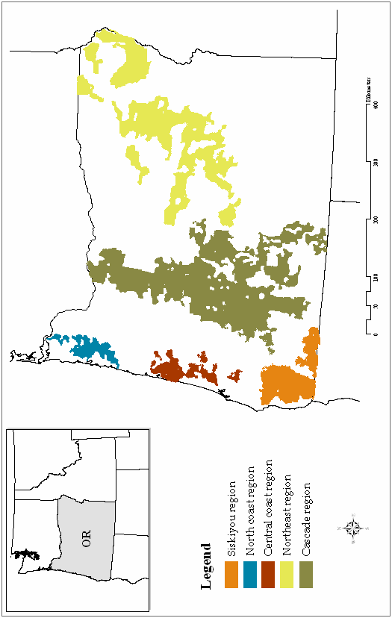
Mladenoff et al. (1995) found deer density not to be related to wolf distribution (8.58 deer/km² in pack territories versus 8.38 deer/km² in non-pack territories) and suggested that the ability of deer to live in close proximity to humans may influence this relationship. Our results corroborate the Great Lakes study and found deer to be at similar densities in random polygons and wolf pack locations (p = 0.07, Table 2). Houts (2000) found elk density to be higher in wolf areas than non-wolf areas (p <0.004) in the Rocky Mountain region. Our results were similar; elk density was approximately 2 times higher in wolf pack areas than non-pack areas (p <0.001, Table 2).
Previous studies (Thiel 1985; Fuller et al. 1992; Mladenoff et al. 1995) in the upper-Midwest found road density to be significantly lower in areas where wolves were present (<0.6 km/km²) than in areas that wolves did not inhabit. Overall, we found road density to be relatively low in our study area compared to the Great Lakes, but road density was still found to be significantly lower in wolf pack locations (0.1 km/km²) than random polygons (0.4 km/km²). We also found that road density did not perform as well as human density, which differs from the Mladenoff et al. study in Wisconsin (Mladenoff et al. 1995; Mladenoff et al. 1999). This may be due to the relatively low road density overall in western states compared to the Great Lake states.
We found human density to be much lower in wolf pack areas (0.2 humans/km²) than non-pack areas (3.3 humans/km²) in our study area which is consistent with other studies from the Great Lakes region (Fuller et al. 1992; Mladenoff et al. 1995) and the Rocky Mountain region (Houts 2000). Mladenoff et al. (1995) found mean human density in Wisconsin to be 1.5 humans/km² in wolf pack areas and 5.2 humans/km² in non-pack areas. Our results were likely due to the low relative human population in the northern Rocky Mountain region and the large amount of wilderness areas that wolves inhabit. Although the LandScan human presence data did not perform as well as census blocks in our habitat models, our results suggest that human impact models may be a valuable tool for assessing wolf or other wildlife habitat assessments. Since the LandScan data are available across the continent and consistent at relatively fine resolution, they may represent an efficient and relatively accurate database for assessing other landscape-scale ecological issues.
Houts (2000) found that wolf habitat in the Rocky Mountain region was characterized by forest cover and public land. In addition, Mladenoff et al. (1995) found wolf packs to include higher percentages of forest cover and public ownership in Wisconsin. Our results tend to corroborate these previous studies and our final model included percent forest cover and percent public land.
Since wolves are still expanding in the study area, wolf absence does not necessarily mean an uninhabited area will not provide wolf habitat. As their populations increase in a given region, wolves will likely inhabit areas with higher road and human densities and possibly less public forested land. However, this study does reflect the habitat characteristics that the expanding population has utilized in the Rocky Mountains and will likely use when dispersing to surrounding areas.

Model selection
While Mladenoff et al. (1995) successfully used stepwise logistic regression to select a wolf habitat model, most natural resource modeling has since shifted to using a priori hypotheses as a means of model creation and selection (Burnham and Anderson 2002). Our study followed the guidelines of Burnham and Anderson (2002) in order to create a robust wolf habitat model for the northwest United States (excluding Washington). The selected prediction model uses public land and forest cover to identify potential wolf habitat in our study area. Although no human presence data were used in the final model, public lands generally have low road and human densities. These variables are therefore indirectly taken into account when determining wolf habitat with the final model.
Although no prey densities were used in the final model, most forested areas contain adequate levels of prey density. In fact, applying the second best model that included elk density, percent forest cover, and percent public ownership (ElkD + %For + %Pub) in Oregon showed only a 0.5% difference from the first model with regard to predicting wolf habitat probability >50%.

Model application
When applied to Oregon, the final model predicted over 68,500 km² of probable wolf habitat (P ≥ 0.5). Most of the contiguous land available for wolves is in the Cascade mountain region, while smaller blocks of land are available in the northeast region, the Klamath region, and the central and northern coastal regions. The relatively small amount of wolf habitat in western Oregon may be underestimated due to the large amount of private industrial forest available that may be considered habitat. Mladenoff et al. (1995) found that wolf pack areas contained more private industrial forest land than non-pack areas. Due to the relatively small amount of private industrial forest and lack of data in the study area outside of the Oregon coastal region, private industrial forest lands were not included in the analysis. However, including western Oregon private industrial forests in post hoc analysis (in conjunction with the public land variable) shows that there is a much greater amount of wolf habitat in western Oregon (Figure 4). In fact, including private industrial forests raises the amount of wolf habitat in western Oregon by more than 23,000 km² (from 45,700 km² to 68,700 km²). Further research is warranted, however, to study wolves in relation to these land types.
Since the wolf data used in our analyses were collected throughout the year, we used year-round ranges for ungulates instead of winter/summer. Because ungulates in the study area migrate primarily by elevation over relatively short distances versus long distance migrations, the final predicted wolf habitat in our analyses will likely incorporate year-round wolf habitat. At various times of the year wolves may migrate relatively short distances to follow ungulate migration, but we feel these movements will likely be from the center to the perimeter of the predicted wolf habitat areas. Modeling winter versus summer habitat, however, would be beneficial research in the future.
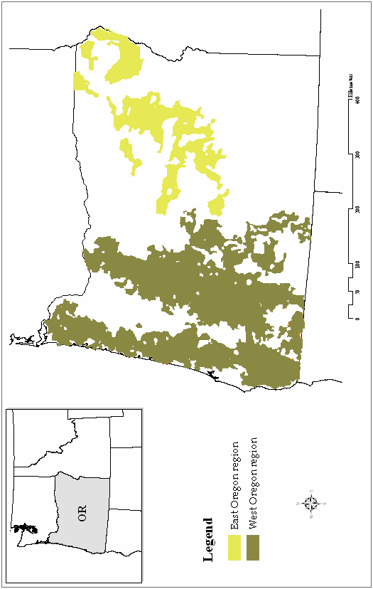
Figure 4: Modeled wolf habitat >50% in Oregon including private industrial forests in western Oregon.
The spatial pattern of available land in Oregon differs from that of Idaho, Montana, and Wyoming. Oregon has less contiguous predicted habitat and more patches spread out over the state which would require wolves to cross areas of unsuitable habitat in order to reach higher quality habitat. Many studies have shown, however, that wolves are able to cross large distances of unsuitable areas while dispersing (Mech 1995; Mech and Boitani 2003). “Pioneering” wolves have been known to disperse over large distances, with mates or in order to find mates, and settle in new habitats far from the nearest source population (Wabakken et al. 2001; Mech and Boitani 2003). Still, unless wolves are given a great deal of protection, wolf recovery beyond the northeast corner of Oregon would likely be a relatively slow process and could take many years before crossing over the Cascades.

Estimating capacity
This research estimates that Oregon is capable of supporting approximately 1450 wolves based on current elk population estimates. This estimate is based on previous studies in relatively stable predator-prey ecosystems throughout North America (Keith 1983; Fuller 1989; Fuller et al. 2003). Since Oregon does not currently have wolves, the predicted capacity could be overestimated depending on the affect the wolf population has on the ungulate population. Wolves will likely cause a decrease in ungulate numbers which, in turn, would lower the capacity of wolves until some equilibrium is reached. Carroll et al. (2001) estimated the wolf capacity for Oregon to be approximately 790 animals based on a model of deer abundance. Our results, however, were based on current elk and deer estimates for each wildlife management unit. In addition, these results increase to approximately 2200 wolves if private industrial lands are included in the analysis, with about three quarters of the estimated wolves located in western Oregon (Figure 4).
The estimated capacities of wolves in the coastal areas are relatively high due to the high densities of black-tailed deer in the coastal range where primary productivity is also relatively high. Although deer density was not found to be related to wolf habitat, deer will inevitably make up a significant portion of the prey biomass, particularly in the western portion of the state. It is unusual for wolf density to be greater than 40 wolves/1000 km², but there are some exceptions including a study on Isle Royale where wolf densities reached as high as 92 wolves/1000 km² (Peterson and Page 1988; Fuller et al. 2003). Fuller (1989) also recorded wolf densities in Minnesota to be as high as 69 wolves/1000 km² within the past 25 years.
It is difficult for wildlife biologists to estimate ungulate populations, especially in western Oregon due to the large amounts of forested land cover. Therefore, confidence intervals on ungulate estimates used are fairly large. In addition, the latest black-tailed deer estimates used in our analysis do not reflect the current population losses of deer due to hair-loss syndrome (ODFW 2001). The lower densities of deer would also limit the wolf estimates. These are the best wolf population estimates that can be provided, however, until more accurate assessments of ungulate populations are available. It is also important to note that these analyses are a “snapshot” of wolf habitat under current policies. Any changes in these policies (e.g. lowering protection) would likely affect numbers of wolves.
Although coastal regions of Washington, Oregon, and northern California are different than Idaho, Montana, and Wyoming, this model could likely be applied to the Northwest United States as an initial means of analyzing wolf habitat for conservation management. The data used in the final model are consistent across states and easily obtainable. Possible future research of wolf habitat modeling could include analysis of wolf habitat in northern coastal areas in British Columbia and Alaska to test the performance of our wolf habitat model in these climates.
Acknowledgements
I would like to thank the Oregon Department of Fish and Wildlife, the Idaho Department of Fish and Game, the Montana Department of Fish, Wildlife, and Parks, and Todd Black from Utah State University for providing the necessary data for this project. I would also like to thank Robert Beschta, Robert Anthony, Betsy Glenn, and Katie Dugger for reviewing and earlier draft of this paper.

Literature Cited
Ballard, W.B., J.S. Whitman, and C.L. Gardner. 1987. Ecology of an exploited wolf population in south-central Alaska. Wildlife Monographs 98:1 – 54.

Boitani, L. 2003. Wolf conservation and recovery. Pp. 317 – 40 in L.D. Mech, and L. Boitani, eds., Wolves: behavior, ecology, and conservation. University of Chicago Press, Chicago, USA.

Boyd, R.J. 1978. American elk. Pp. 11 – 29 in J.L. Schmidt and D.L. Gilbert, eds., Big game of North America: Ecology and management. Stackpole, Harrisburg, PA.

Burnham, K.P., and D.R. Anderson. 2002. Model selection and multimodel inference: A practical information-theoretic approach (second edition). Springer, New York, USA.

Carbyn, L.N., S.M. Oosenbrug, and D.W. Anions. 1993. Wolves, bison and the dynamics related to the Peace Athabasca Delta in Canada’s Wood Buffolo National Park. Circumpolar Research Series, no. 4. Canadian Circumpolar institute, University of Alberta, Edmonton.

Carroll, C., P.C. Paquet, R.F. Noss. 2000. Modeling carnivore habitat in the Rocky Mountain region: a literature review and suggested strategy. World Wildlife Fund Canada, Toronto, Ontario, Canada.

Carroll, C., R.F. Noss, N.H. Schumaker, and P.C. Paquet. 2001. Is the return of the wolf, wolverine, and grizzly bear to Oregon and California biologically feasible? Pp. 25 - 46 in D. S. Maehr, R.F. Noss, and J.L. Larkin, eds., Large Mammal Restoration. Island Press, Washington.

Carroll, C., M.K. Phillips, N.H. Schumaker, D.W. Smith. 2002. Impacts of landscape change on wolf restoration success: Planning a reintroduction program based on static and dynamic spatial models. Conservation Biology 17:536 - 548.

Clark, J.D., J.E. Dunn, and K.G. Smith. 1993. A multivariate model of female black bear habitat use for a geographic information system. Journal of Wildlife Management 57:519 - 526.

Corsi, F., E. Dupre, and L. Boitani. 1999. A large-scale model of wolf distribution in Italy for conservation planning. Conservation Biology 13:150 - 159.

Crist, E.P., and R.C. Cicone. 1984. Application of the tassled cap concept to simulated thematic mapper data. Photogrammetric Engineering and Remote Sensing 50:343 - 352.

Daly, C., W. Gibson, and G. Taylor. 2002. 103 - Year High Resolution Precipitation Climate Data Set for the Conterminous United States. Spatial Climate Analysis Service, Oregon, Corvallis, OR.

Dobson, J.E., E.A. Bright, P.R. Coleman, R.C. Durfee, B.A. Worley. 2000. LandScan: A global population database for estimating populations at risk. Photogrammetric Engineering and Remote Sensing 66:849 - 857.

Fernandez, N., M. Delibes, F. Palomares, and D. Mladenoff. 2003. Identifying breeding habitat for the Iberian lynx; Inferences from a fine-scale spatial analysis. Ecological Applications 13:1310 - 1324.

Fritts, S.H., R.O. Stephenson, R.D. Hayes, and L. Boitani. 2003. Wolves and humans. Pp. 289 – 316 in L.D. Mech, and L. Boitani, eds., Wolves: behavior, ecology, and conservation. University of Chicago Press, Chicago, USA.

Fuller, T.K. 1989. Population dynamics of wolves in north-central Minnesota. Wildlife Monographs 105:1 - 41.

Fuller, T.K. 1995. Comparative population dynamics of North American wolves and African wild dogs. Pp. 325-28 in L. N. Carbyn, S.H. Fritts, and D.R. Seip, eds., Ecology and Conservation of Wolves in a Changing World. Canadian Circumpolar Institute, University of Alberta, Edmonton.

Fuller, T.K., W.E. Berg, G.L. Radde, M.S. Lenarz, and G.B. Joselyn. 1992. A history and current estimate of wolf distribution and numbers in Minnesota. Wildlife Society Bulletin 20:42 - 55.

Fuller, T.K., L.D. Mech, and J.F. Cochrane. 2003. Wolf Population Dynamics. Pp. 161 - 91 in L.D. Mech, and L. Boitani, eds., Wolves: behavior, ecology, and conservation. University of Chicago Press, Chicago, USA.

Haight, R.G., D.J. Mladenoff, and A.P. Wydeven. 1998. Modeling disjunct gray wolf populations in semi-wild landscapes. Conservation Biology 12:879 - 888.

Hebblewhite, M., and D.H. Pletscher. 2002. Effects of elk group size on predation by wolves. Canadian Journal of Zoology 80:800 - 809.

Hebblewhite, M., D.H. Pletscher, and P.C. Paquet. 2002. Elk population dynamics in areas with and without predation by recolonizing wolves in Banff National Park. Canadian Journal of Zoology 80:789 - 799.

Houts, M.E. 2000. Modeling gray wolf habitat in the Northern Rocky Mountains. M.S. thesis, University of Kansas, Lawrence. 130 pp.

Huggard, D.J. 1993a. Effect of snow depth on predation and scavenging by gray wolves. Journal of Wildlife Management 57:382 – 88.

Huggard, D.J. 1993b. Prey selectivity of wolves in Banff National Park. I. Prey species. Canadian Journal of Zoology 71:130 – 39.

Jedrzejewski, W., K. Schmidt, J. Theuerkauf, B. Jedrzejewska, N. Selva, K. Zub, and L. Szymura. 2002. Kill rates and predation by wolves on ungulate populations in Bialowieza Primeval Forest (Poland). Ecology 83:1341 – 56.

Jensen, W.F., T.K. Fuller, and W.L. Robinson. 1986. Wolf (Canis lupus) distribution on the Ontario-Michigan border near Sault Ste. Marie. Canadian Field-Naturalist 100:363 - 366.

Keith, L.B. 1983. Population dynamics of wolves. in L.N. Carbyn, editor. Wolves in Canada and Alaska: Their status, biology, and management. Report Series, no. 45. Canadian Wildlife Service, Edmonton, Alberta.

Light, D.S., and S.H. Fritts. 1994. Gray wolf (Canis lupus) occurences in the Dakotas. American Midland Naturalist 121:387 - 389.

Mech, L.D. 1970. The wolf: the ecology and behavior of an endangered species. Natural History Press, New York.

Mech, L.D. 1989. Wolf population survival in an area of high road density. American Midland Naturalist 121:387 - 389.

Mech, L.D. 1995. The challenge and opportunity of recovering wolf populations. Conservation Biology 9:270 - 278.

Mech, L.D., and L. Boitani. 2003. Wolf social ecology. Pp. 1 – 34 in L.D. Mech, and L. Boitani, eds., Wolves: behavior, ecology, and conservation. University of Chicago Press, Chicago, USA.

Mech, L.D., S.H. Fritts, G. Radde, and W.J. Paul. 1988. Wolf distribution and road density in Minnesota. Wildlife Society Bulletin 16:85 - 87.
Mech, L.D., S.H. Fritts, and D. Wagner. 1995. Minnesota wolf dispersal to Wisconsin and Michigan. American Midland Naturalist 133:368 - 370.

Mech, L.D., and S.M. Goyal. 1993. Canine parvovirus effect on wolf population change and pup survival. Journal of Wildlife Management 62:1 - 10.

Mech, L.D., and R.O. Peterson. 2003. Wolf-prey relations. Pp. 131 – 60 in L.D. Mech, and L. Boitani, eds., Wolves: behavior, ecology, and conservation. University of Chicago Press, Chicago, USA.

Merrill, S.B. 2000. Road densities and Gray Wolf, Canis lupus, habitat suitability: an exception. Canadian Field-Naturalist 114:312 - 313.

Miller, D.H., A.L. Jensen, and J.H. Hammill. 2002. Density dependent matrix model for gray wolf population projection. Ecological Modeling 151:271 - 278.

Mladenoff, D.J., and T.A. Sickley. 1998. Assessing potential gray wolf restoration in the northeastern United States: A spatial prediction of favorable habitat and potential population levels. Journal of Wildlife Management 62:1 - 10.

Mladenoff, D.J., T.A. Sickley, R.G. Haight, and A.P. Wydeven. 1995. A regional landscape analysis and prediction of favorable gray wolf habitat in northern Great Lakes region. Conservation Biology 9:279 - 294.

Mladenoff, D.J., T.A. Sickley, and A.P. Wydeven. 1999. Predicting gray wolf landscape recolonization: Logistic regression models vs. new field data. Ecological Applications 9:37 - 44.

Nelson, M.E., and L.D. Mech. 1986. Relationship between snow depth and gray wolf predation on white-tailed deer. Journal of Wildlife Management 50:471 - 474.

Oregon Department of Fish and Wildlife. 2001. Black-tailed deer hair loss syndrome. Oregon Department of Fish and Wildlife [online]. Available: http://www.dfw.state.or.us/ODFWhtml/InfoCntrWild/btd_hairloss.htm [February 2004].

Oregon Department of Fish and Wildlife. 2003. An introduction to Oregon wolf issues. Oregon Department of Fish and Wildlife [online]. Available: http://www.dfw.state.or.us/ODFWhtml/InfoCntrWild/gray_wolf/wolf_main.htm [March 2003].

Paquet, P.C., J. Wierzchowski, and C. Callaghan. 1996. Effects of human activity on gray wolves in the Bow River Valley, Banff National Park, Alberta. in J. Green, C. Pacas, S. Bayley, and L. Cornwell, editor. A Cumulative Effects Assessment and Futures Outlook for the Banff Bow Valley. Prepared for the Banff Bow Valley Study. Department of Canadian Heritage, Ottawa.

Peterson, R.O. 1999. Wolf-moose interaction on Isle Royale: The end of natural regulation? Ecological Applications 9:10 – 16.

Peterson, R.O., and Ciucci, P. 2003. The wolf as a carnivore. Pp. 105 – 30 in L.D. Mech, and L. Boitani, eds., Wolves: behavior, ecology, and conservation. University of Chicago Press, Chicago, USA.

Peterson, R.O., and R.E. Page. 1988. The rise and fall of the Isle Royale wolves. Journal of Mammology 69:89 – 99.

Pletscher, D.H., R.R. Ream, D.K. Boyd, M.W. Fairchild, and K.E. Kunkel. 1997. Population dynamics of a recolonizing wolf population. Journal of Wildlife Management 61:459 – 465.

Schadt, S., E. Revilla, T. Wiegand, F. Knauer, P. Kaczensky, U. Breitenmoser, l. Bufka, J. Cerveny, P. Koubek, T. Huber, C. Stanisa, and L. Trepl. 2002. Assessing the suitability of central European landscapes for the reintroduction of Eurasian lynx. Journal of Applied Ecology 39:189 - 203.

Singleton, P.H., W.L. Gaines, and J.F. Lehmkuhl. 2002. Landscape permeability for large carnivores in Washington: A Geographic Information System weighted-distance and least-cost corridor assessment. Res. Pap. PNW-RP-549, U.S. Department of Agriculture, Forest Service, Pacific Northwest Research Station, Portland, OR.

Smith, D.W., L.D. Mech, M. Meagher, W.E. Clark, R. Jaffe, M.K. Phillips, and J.A. Mack. 2000. Wolf-bison interactions in Yellowstone National Park. Journal of Mammalogy 81:1128 - 1135.

Thiel, R.P. 1985. Relationship between road densities and wolf habitat suitability in Wisconsin. American Midland Naturalist 113:404 - 407.

Thurber, J.M., R.O. Peterson, T.R. Drummer, and S.A. Thomasma. 1994. Gray wolf response to refuge boundaries and roads in Alaska. Wildlife Society Bulletin 22:61 - 68.

U.S. Fish and Wildlife Service (USFWS), Nez Perce Tribe, National Park Service, and USDA Wildlife Services. 2002. Rocky Mountain Wolf Recovery 2001 Annual Report. T. Meier, ed. USFWS, Ecological Services, 100 N Park, Suite 320, Helena MT. 43 pp.

U.S. Fish and Wildlife Service (USFWS), Nez Perce Tribe, National Park Service, and USDA Wildlife Services. 2004. Rocky Mountain Wolf Recovery 2003 Annual Report. T. Meier, ed. USFWS, Ecological Services, 100 N Park, Suite 320, Helena MT. 65 pp.

Wabakken, P., H. Sand, O Liberg, and A. Bjarvall. 2001. The recovery, distribution, and population dynamics of wolves on the Scandinavian peninsula, 1978 – 1998. Canadian Journal of Zoology 79:710 – 25.

Weaver, J.L. 1994. Ecology of wolf predation amidst high ungulate diversity in Jasper National Park, Alberta. Ph.D. dissertation, University of Montana, Missoula. 183 pp.

CHAPTER 3
CONCLUSION

Conservation of large carnivores has been an important focus of ecological research over the past few decades. As managers struggle to incorporate the needs of wolves and other large predators in human dominated landscapes, they increasingly need better information for ensuring the sustainability of both animals and humans. Habitat modeling offers managers a means to make informed decisions based on the best data available.
As gray wolves begin dispersing from Idaho into Oregon, wildlife managers need to know where potential wolf habitat is located throughout the state. This research uses a GIS and habitat variables from wolf packs in Idaho, Montana, and Wyoming to model wolf habitat in Oregon. The results from this research can be used to identify locations in Oregon that wolves are likely to inhabit in addition to the number of wolves each habitat region could potentially support. Future research should be directed into modeling wolf habitat in other western states such as Washington and northern California. As GIS and other natural resource tools continually improve, habitat models will hopefully become more accurate and more valuable to constructing, implementing, and monitoring future wildlife management plans.

Bibliography
Bailey, V. 1936. The mammals and life zones of Oregon. U.S. Department of Agriculture. North American Fauna No. 55. 416pp.

Ballard, W.B., J.S. Whitman, and C.L. Gardner. 1987. Ecology of an exploited wolf population in south-central Alaska. Wildlife Monographs 98:1 – 54.

Boitani, L. 2003. Wolf conservation and recovery. Pp. 317 – 40 in L.D. Mech, and L. Boitani, eds., Wolves: behavior, ecology, and conservation. University of Chicago Press, Chicago, USA.

Boyd, D.K., P.C. Paquet, S. Donelon, R.R. Ream, D.H. Pletscher, and C.C. White. 1995. Transboundary movements of a recolonizing wolf population in the Rocky Mountains. in L. N. Carbyn, S.H. Fritts, and D.R. Seip, editor. Ecology and Conservation of Wolves in a Changing World. Canadian Circumpolar Institute, University of Alberta, Edmonton.

Boyd, R.J. 1978. American elk. Pp. 11 – 29 in J.L. Schmidt and D.L. Gilbert, eds., Big game of North America: Ecology and management. Stackpole, Harrisburg, PA.

Burnham, K.P., and D.R. Anderson. 2002. Model selection and multimodel inference: A practical information-theoretic approach (second edition). Springer, New York, USA.

Carbyn, L.N., S.M. Oosenbrug, and D.W. Anions. 1993. Wolves, bison and the dynamics related to the Peace Athabasca Delta in Canada’s Wood Buffolo National Park. Circumpolar Research Series, no. 4. Canadian Circumpolar institute, University of Alberta, Edmonton.

Carroll, C., P.C. Paquet, R.F. Noss. 2000. Modeling carnivore habitat in the Rocky Mountain region: a literature review and suggested strategy. World Wildlife Fund Canada, Toronto, Ontario, Canada.

Carroll, C., R.F. Noss, N.H. Schumaker, and P.C. Paquet. 2001. Is the return of the wolf, wolverine, and grizzly bear to Oregon and California biologically feasible? Pp. 25 - 46 in D. S. Maehr, R.F. Noss, and J.L. Larkin, eds., Large Mammal Restoration. Island Press, Washington.

Carroll, C., M.K. Phillips, N.H. Schumaker, D.W. Smith. 2002. Impacts of landscape change on wolf restoration success: Planning a reintroduction program based on static and dynamic spatial models. Conservation Biology 17:536 - 548.

Clark, J.D., J.E. Dunn, and K.G. Smith. 1993. A multivariate model of female black bear habitat use for a geographic information system. Journal of Wildlife Management 57:519 - 526.

Corsi, F., E. Dupre, and L. Boitani. 1999. A large-scale model of wolf distribution in Italy for conservation planning. Conservation Biology 13:150 - 159.

Crist, E.P., and R.C. Cicone. 1984. Application of the tassled cap concept to simulated thematic mapper data. Photogrammetric Engineering and Remote Sensing 50:343 - 352.

Daly, C., W. Gibson, and G. Taylor. 2002. 103 - Year High Resolution Precipitation Climate Data Set for the Conterminous United States. Spatial Climate Analysis Service, Oregon, Corvallis, OR.

Dobson, J.E., E.A. Bright, P.R. Coleman, R.C. Durfee, B.A. Worley. 2000. LandScan: A global population database for estimating populations at risk. Photogrammetric Engineering and Remote Sensing 66:849 - 857.

Fernandez, N., M. Delibes, F. Palomares, and D. Mladenoff. 2003. Identifying breeding habitat for the Iberian lynx; Inferences from a fine-scale spatial analysis. Ecological Applications 13:1310 - 1324.

Fritts, S.H., R.O. Stephenson, R.D. Hayes, and L. Boitani. 2003. Wolves and humans. Pp. 289 – 316 in L.D. Mech, and L. Boitani, eds., Wolves: behavior, ecology, and conservation. University of Chicago Press, Chicago, USA.

Fuller, T.K. 1989. Population dynamics of wolves in north-central Minnesota. Wildlife Monographs 105:1 - 41.

Fuller, T.K. 1995. Comparative population dynamics of North American wolves and African wild dogs. Pp. 325-28 in L.N. Carbyn, S.H. Fritts, and D.R. Seip, eds., Ecology and Conservation of Wolves in a Changing World. Canadian Circumpolar Institute, University of Alberta, Edmonton.

Fuller, T. K., W.E. Berg, G.L. Radde, M.S. Lenarz, and G.B. Joselyn. 1992. A history and current estimate of wolf distribution and numbers in Minnesota. Wildlife Society Bulletin 20:42 - 55.

Fuller, T.K., L.D. Mech, and J.F. Cochrane. 2003. Wolf Population Dynamics. Pp. 161 - 91 in L.D. Mech, and L. Boitani, eds., Wolves: behavior, ecology, and conservation. University of Chicago Press, Chicago, USA.

Haight, R.G., D.J. Mladenoff, and A.P. Wydeven. 1998. Modeling disjunct gray wolf populations in semi-wild landscapes. Conservation Biology 12:879 - 888.

Hebblewhite, M., and D.H. Pletscher. 2002. Effects of elk group size on predation by wolves. Canadian Journal of Zoology 80:800 - 809.

Hebblewhite, M., D.H. Pletscher, and P.C. Paquet. 2002. Elk population dynamics in areas with and without predation by recolonizing wolves in Banff National Park. Canadian Journal of Zoology 80:789 - 799.

Houts, M.E. 2000. Modeling gray wolf habitat in the Northern Rocky Mountains. M.S. thesis, University of Kansas, Lawrence. 130 pp.

Huggard, D.J. 1993a. Effect of snow depth on predation and scavenging by gray wolves. Journal of Wildlife Management 57:382 – 88.

Huggard, D.J. 1993b. Prey selectivity of wolves in Banff National Park. I. Prey species. Canadian Journal of Zoology 71:130 – 39.

Jedrzejewski, W., K. Schmidt, J. Theuerkauf, B. Jedrzejewska, N. Selva, K. Zub, and L. Szymura. 2002. Kill rates and predation by wolves on ungulate populations in Bialowieza Primeval Forest (Poland). Ecology 83:1341 – 56.

Jensen, W.F., T.K. Fuller, and W.L. Robinson. 1986. Wolf (Canis lupus) distribution on the Ontario-Michigan border near Sault Ste. Marie. Canadian Field-Naturalist 100:363 - 366.

Keith, L.B. 1983. Population dynamics of wolves. in L.N. Carbyn, editor. Wolves in Canada and Alaska: Their status, biology, and management. Report Series, no. 45. Canadian Wildlife Service, Edmonton, Alberta.

Light, D.S., and S.H. Fritts. 1994. Gray wolf (Canis lupus) occurences in the Dakotas. American Midland Naturalist 121:387 - 389.

Mech, L.D. 1970. The wolf: the ecology and behavior of an endangered species. Natural History Press, New York.

Mech, L.D. 1989. Wolf population survival in an area of high road density. American Midland Naturalist 121:387 - 389.

Mech, L.D. 1995. The challenge and opportunity of recovering wolf populations. Conservation Biology 9:270 - 278.

Mech, L.D., and L. Boitani. 2003. Wolf social ecology. Pp. 1 – 34 in L.D. Mech, and L. Boitani, eds., Wolves: behavior, ecology, and conservation. University of Chicago Press, Chicago, USA.

Mech, L.D., S.H. Fritts, G. Radde, and W.J. Paul. 1988. Wolf distribution and road density in Minnesota. Wildlife Society Bulletin 16:85 - 87.

Mech, L.D., S.H. Fritts, and D. Wagner. 1995. Minnesota wolf dispersal to Wisconsin and Michigan. American Midland Naturalist 133:368 - 370.

Mech, L.D., and S.M. Goyal. 1993. Canine parvovirus effect on wolf population change and pup survival. Journal of Wildlife Management 62:1 - 10.

Mech, L.D., and R.O. Peterson. 2003. Wolf-prey relations. Pp. 131 – 60 in L.D. Mech, and L. Boitani, eds., Wolves: behavior, ecology, and conservation. University of Chicago Press, Chicago, USA.

Merrill, S.B. 2000. Road densities and Gray Wolf, Canis lupus, habitat suitability: an exception. Canadian Field-Naturalist 114:312 - 313.

Miller, D.H., A.L. Jensen, and J.H. Hammill. 2002. Density dependent matrix model for gray wolf population projection. Ecological Modeling 151:271 - 278.

Mladenoff, D.J., and T.A. Sickley. 1998. Assessing potential gray wolf restoration in the northeastern United States: A spatial prediction of favorable habitat and potential population levels. Journal of Wildlife Management 62:1 - 10.

Mladenoff, D.J., T.A. Sickley, R.G. Haight, and A.P. Wydeven. 1995. A regional landscape analysis and prediction of favorable gray wolf habitat in northern Great Lakes region. Conservation Biology 9:279 - 294.

Mladenoff, D.J., T.A. Sickley, and A.P. Wydeven. 1999. Predicting gray wolf landscape recolonization: Logistic regression models vs. new field data. Ecological Applications 9:37 - 44.

Nelson, M.E., and L.D. Mech. 1986. Relationship between snow depth and gray wolf predation on white-tailed deer. Journal of Wildlife Management 50:471 - 474.

Oregon Department of Fish and Wildlife. 2001. Black-tailed deer hair loss syndrome. Oregon Department of Fish and Wildlife [online]. Available: http://www.dfw.state.or.us/ODFWhtml/InfoCntrWild/btd_hairloss.htm [February 2004].

Oregon Department of Fish and Wildlife. 2003. An introduction to Oregon wolf issues. Oregon Department of Fish and Wildlife [online]. Available: http://www.dfw.state.or.us/ODFWhtml/InfoCntrWild/gray_wolf/wolf_main.htm [March 2003].

Paquet, P.C., J. Wierzchowski, and C. Callaghan. 1996. Effects of human activity on gray wolves in the Bow River Valley, Banff National Park, Alberta. in J. Green, C. Pacas, S. Bayley, and L. Cornwell, editor. A Cumulative Effects Assessment and Futures Outlook for the Banff Bow Valley. Prepared for the Banff Bow Valley Study. Department of Canadian Heritage, Ottawa.

Peterson, R.O. 1999. Wolf-moose interaction on Isle Royale: The end of natural regulation? Ecological Applications 9:10 – 16.

Peterson, R.O., and Ciucci, P. 2003. The wolf as a carnivore. Pp. 105 – 30 in L.D. Mech, and L. Boitani, eds., Wolves: behavior, ecology, and conservation. University of Chicago Press, Chicago, USA.

Peterson, R.O., and R.E. Page. 1988. The rise and fall of the Isle Royale wolves. Journal of Mammology 69:89 – 99.

Pletscher, D.H., R.R. Ream, D.K. Boyd, M.W. Fairchild, and K.E. Kunkel. 1997. Population dynamics of a recolonizing wolf population. Journal of Wildlife Management 61:459 – 465.

Schadt, S., E. Revilla, T. Wiegand, F. Knauer, P. Kaczensky, U. Breitenmoser, l. Bufka, J. Cerveny, P. Koubek, T. Huber, C. Stanisa, and L. Trepl. 2002. Assessing the suitability of central European landscapes for the reintroduction of Eurasian lynx. Journal of Applied Ecology 39:189 - 203.

Singleton, P.H., W.L. Gaines, and J.F. Lehmkuhl. 2002. Landscape permeability for large carnivores in Washington: A Geographic Information System weighted-distance and least-cost corridor assessment. Res. Pap. PNW-RP-549, U.S. Department of Agriculture, Forest Service, Pacific Northwest Research Station, Portland, OR.

Smith, D.W., L.D. Mech, M. Meagher, W.E. Clark, R. Jaffe, M.K. Phillips, and J.A. Mack. 2000. Wolf-bison interactions in Yellowstone National Park. Journal of Mammalogy 81:1128 - 1135.

Thiel, R.P. 1985. Relationship between road densities and wolf habitat suitability in Wisconsin. American Midland Naturalist 113:404 - 407.

Thurber, J.M., R.O. Peterson, T.R. Drummer, and S.A. Thomasma. 1994. Gray wolf response to refuge boundaries and roads in Alaska. Wildlife Society Bulletin 22:61 - 68.

U.S. Fish and Wildlife Service (USFWS), Nez Perce Tribe, National Park Service, and USDA Wildlife Services. 2002. Rocky Mountain Wolf Recovery 2001 Annual Report. T. Meier, ed. USFWS, Ecological Services, 100 N Park, Suite 320, Helena MT. 43 pp.

U.S. Fish and Wildlife Service (USFWS), Nez Perce Tribe, National Park Service, and USDA Wildlife Services. 2004. Rocky Mountain Wolf Recovery 2003 Annual Report. T. Meier, ed. USFWS, Ecological Services, 100 N Park, Suite 320, Helena MT. 65 pp.

Wabakken, P., H. Sand, O Liberg, and A. Bjarvall. 2001. The recovery, distribution, and population dynamics of wolves on the Scandinavian peninsula, 1978 – 1998. Canadian Journal of Zoology 79:710 – 25.

Weaver, J.L. 1994. Ecology of wolf predation amidst high ungulate diversity in Jasper National Park, Alberta. Ph.D. dissertation, University of Montana, Missoula. 183 pp.

Wuerthner, G. 1996. Potential for wolf recovery in Oregon. in N. Fascione, and M. Cecil, editor. Defenders of Wildlife's Wolves of America Conference.

Young, S.P., and E.A. Goldman. 1964. Wolves of North America. Dover, New York.

APPENDICES

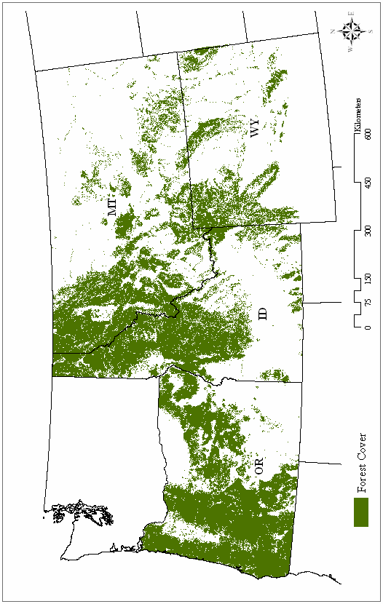
Appendix 1: Forest cover in the study area.
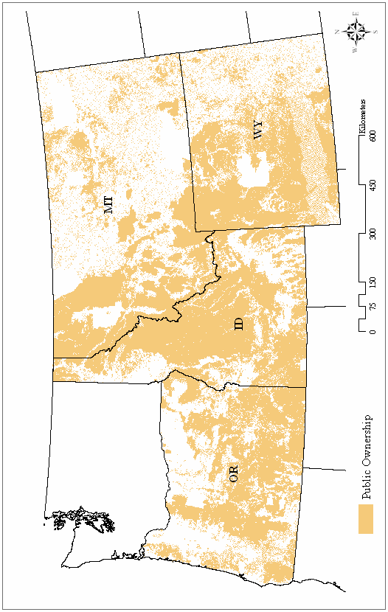
Appendix 2: Public ownership in the study area.
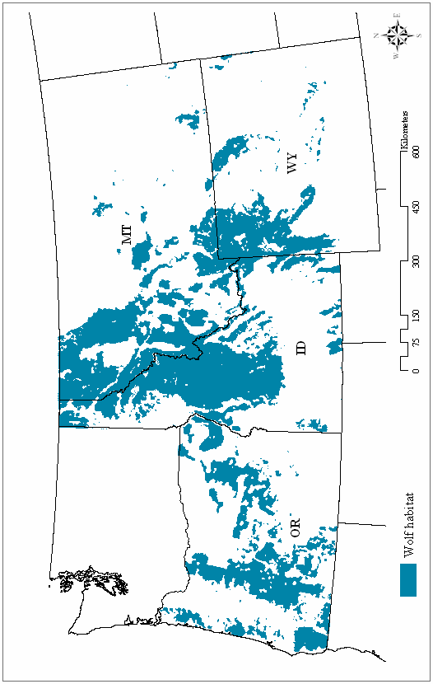
Appendix 3: Wolf habitat predicted by the final model >50% in the study area.

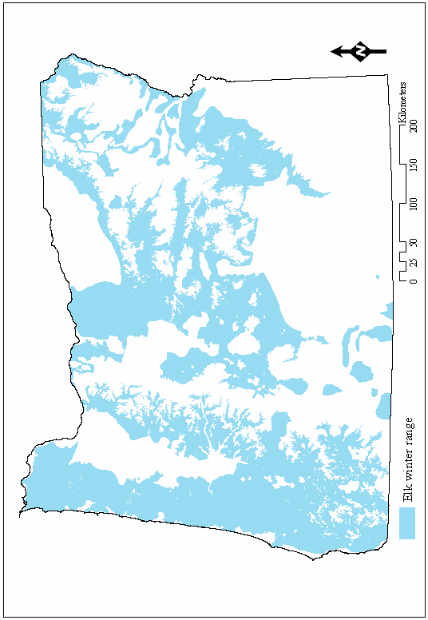
Appendix 4: Elk winter range in Oregon.

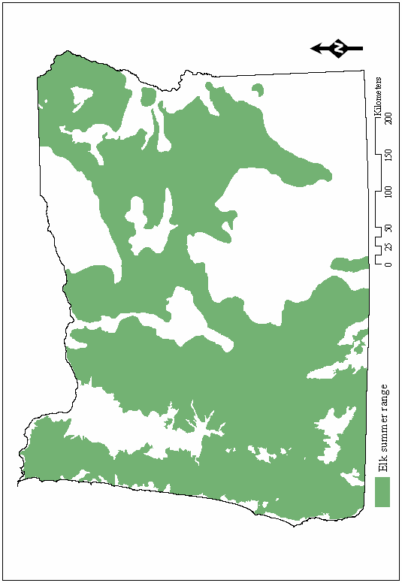
Appendix 5: Elk summer range in Oregon.

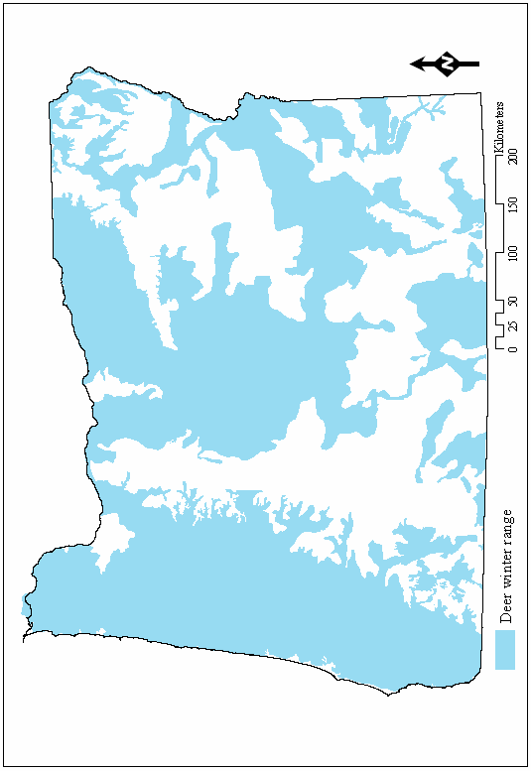
Appendix 6: Deer winter range in Oregon.

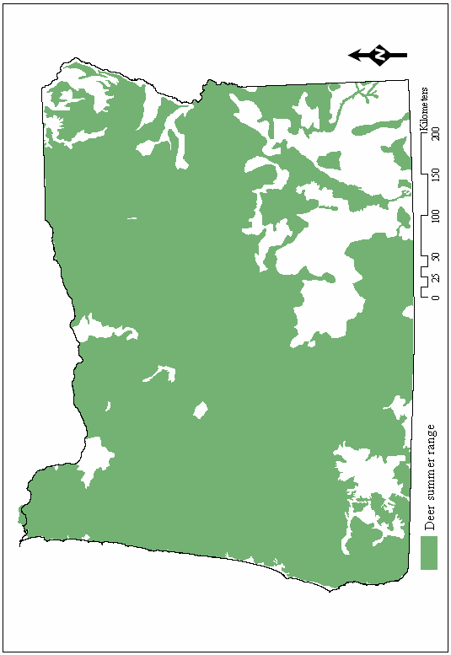
Appendix 7: Deer summer range in Oregon.

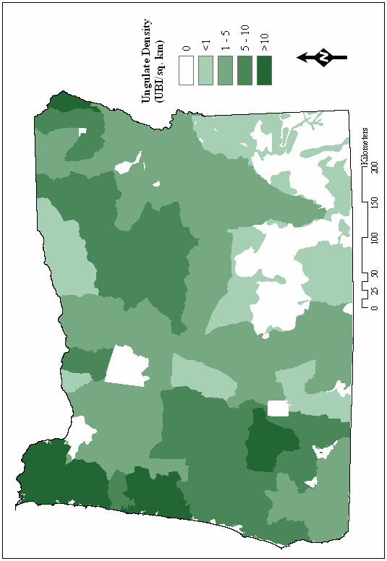
Appendix 8: Ungulate density (Ungulate Biomass Index/sq. km).

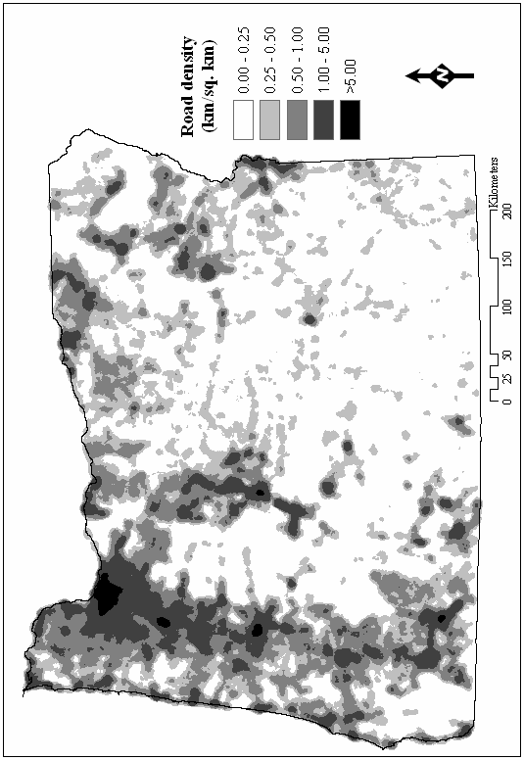
Appendix 9: Road density in Oregon (km/sq. km).

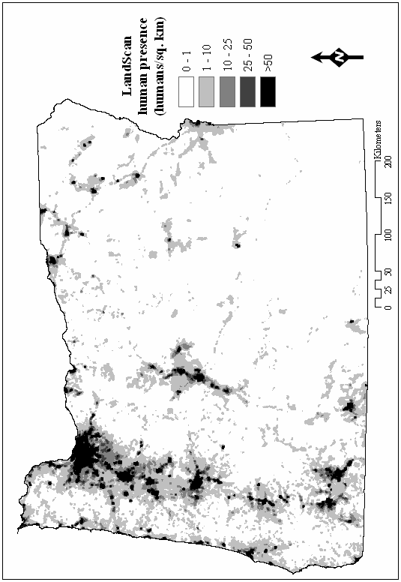
Appendix 10: LandScan human presence data (humans/sq. km).

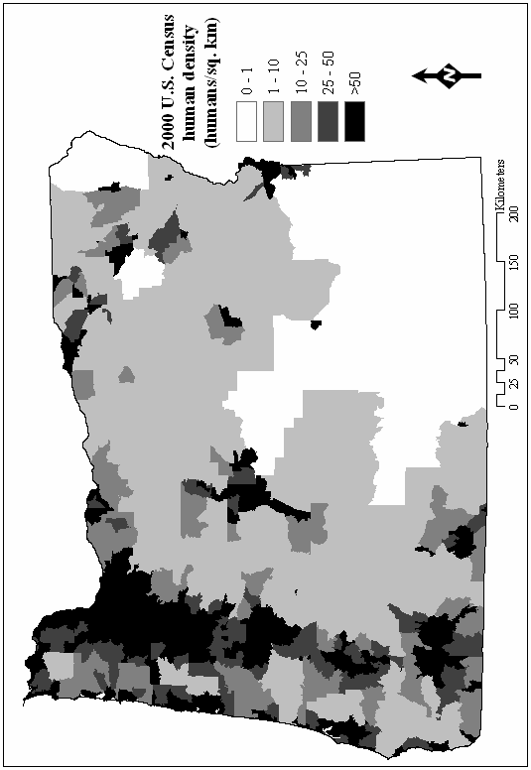
Appendix 11: 2000 U.S. Census bureau human density (humans/sq. km).

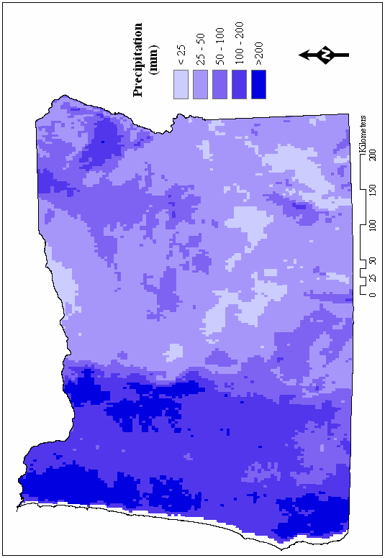
Appendix 12: Precipitation in Oregon (mm.).
Appendix 14: Ungulate population estimates by wildlife management unit.

Wildlife Management Unit | Elk Population | Deer Population | Ungulate Biomass Index
SADDLE MT. | 7700 | 9500 | 32600
SCAPPOOSE | 2100 | 17000 | 23300
CHESNIMNUS | 2900 | 3500 | 12200
SLED SPRINGS | 2150 | 4700 | 11150
WENAHA | 1400 | 1200 | 5400
WALLA WALLA | 1500 | 1615 | 6115
COLUMBIA BASIN | 416 | 1200 | 2448
WILSON | 5400 | 10200 | 26400
SNAKE RIVER | 3350 | 2600 | 12650
MT EMILY | 4600 | 4800 | 18600
BIGGS | 416 | 6500 | 7748
HOOD | 110 | 400 | 730
WHITE RIVER | 1100 | 9000 | 12300
TRASK | 5200 | 25500 | 41100
UKIAH | 5000 | 6767 | 21767
WILLAMETTE | 100 | 15600 | 15900
MINAM | 2000 | 3300 | 9300
SANTIAM | 5400 | 26900 | 43100
CATHERINE CREEK | 600 | 1800 | 3600
IMNAHA | 1100 | 4700 | 8000
HEPPNER | 2660 | 12825 | 20805
STARKEY | 4700 | 4500 | 18600
MAUPIN | 416 | 3060 | 4308
PINE CREEK | 500 | 2550 | 4050
FOSSIL | 2400 | 11900 | 19100
KEATING | 216 | 4370 | 5018
STOTT MT. | 1255 | 4800 | 8565
SUMPTER | 2031 | 7130 | 13223
DESOLATION | 1365 | 2174 | 6269
ALSEA | 4095 | 68300 | 80585
GRIZZLY | 1500 | 3500 | 8000
LOOKOUT MT. | 470 | 3470 | 4880
NORTHSIDE | 2300 | 13917 | 20817
METOLIUS | 200 | 5300 | 5900
OCHOCO | 4600 | 18000 | 31800
BEULAH | 1900 | 13000 | 18700
MCKENZIE | 5200 | 30300 | 45900
Wildlife Management Unit | Elk Population | Deer Population | Ungulate Biomass Index
MURDERERS CREEK | 1800 | 9900 | 15300
UPPER DESCHUTES | 500 | 1900 | 3400
PAULINA | 1100 | 15400 | 18700
SIUSLAW | 1500 | 26300 | 30800
MALHEUR RIVER | 1400 | 11800 | 16000
MAURY | 900 | 4500 | 7200
SILVIES | 2300 | 8850 | 15750
OWYHEE | 0 | 4900 | 4900
INDIGO | 2000 | 24000 | 30000
WAGONTIRE | 300 | 1240 | 2140
MELROSE | 1400 | 12900 | 17100
TIOGA | 8000 | 8300 | 32300
FORT ROCK | 3650 | 9000 | 19950
STEENS MT. | 0 | 5360 | 5360
JUNIPER | 0 | 1495 | 1495
SIXES | 1750 | 15000 | 20250
DIXON | 2775 | 33000 | 41325
ROGUE | 1650 | 20400 | 25350
SILVER LAKE | 0 | 7000 | 7000
POWERS | 1400 | 5300 | 9500
CRATER LAKE N. P. | 0 | 0 | 0
WHITEHORSE | 0 | 1500 | 1500
EVANS CREEK | 600 | 11400 | 13200
SPRAGUE | 200 | 300 | 900
KENO | 200 | 1568 | 2168
WARNER | 150 | 0 | 450
INTERSTATE | 0 | 6909 | 6909
BEATYS BUTTE | 0 | 1100 | 1100
CHETCO | 1000 | 14400 | 17400
KLAMATH FALLS | 0 | 3410 | 3410
APPLEGATE | 100 | 13000 | 13300
WMSP INDIAN RES. | 0 | 0 | 0

